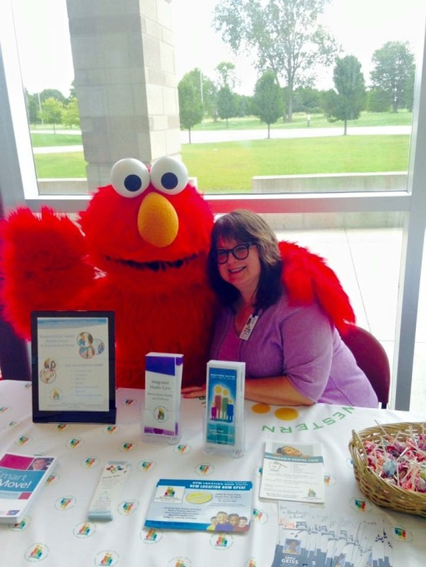
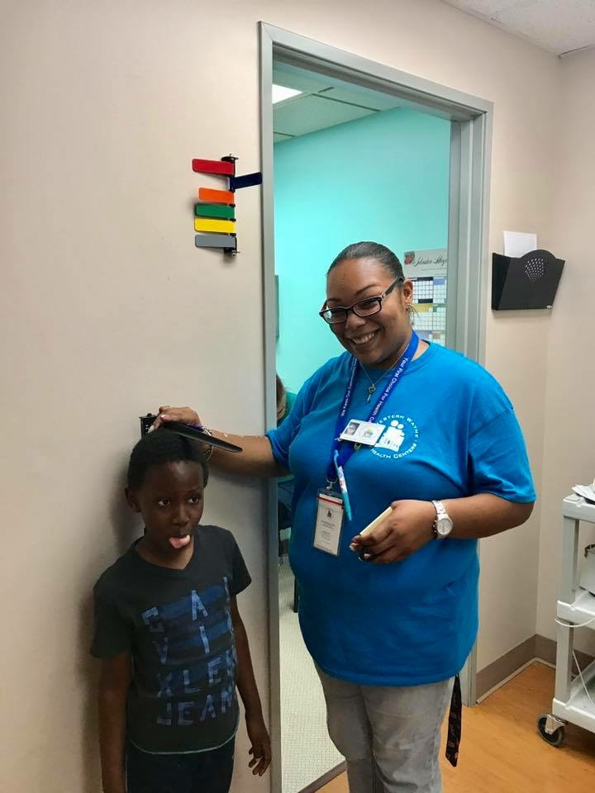

Career Opportunities
To meet the needs of the people in the communities we serve requires a group of talented and committed staff members. Western Wayne Family Health Centers values the skills, diversity, strong work ethic and passion that each employee invests in providing quality services to those we help.
Western Wayne Family Health Centers is an equal opportunity employer and is always looking for individuals who are ready to provide exceptional service to the communities we serve.
Check out our openings:
Medical Assistant with OB/GYN experience
Dental Assistant
Licensed Practical Nurse
Family Physician – Internal Medicine
Nurse Practitioner
Clinical Office Manager

We offer a competitive salary and benefit incentive package!
Applications are available at each location or you may submit a completed application along with an updated resume to humanresources@wwfhc.org.

